Rodmersham Feedback Policy

At Rodmersham School, we recognise the importance of feedback as part of the teaching & learning cycle and aim to maximise the effectiveness of its use in practice. We are mindful also of the workload implications of written marking, and of the research surrounding effective feedback. Our policy is underpinned by the evidence of best practice from the Education Endowment Foundation, other experts as well as Pupil Voice results.

Research
Research suggests that providing feedback is one of the most effective and cost-effective ways of improving students’ learning. The studies of feedback reviewed in the Teaching and Learning Toolkit – an evidence synthesis produced by the EEF, Sutton Trust and Durham University – found that, on average, the provision of high-quality feedback led to an improvement of eight additional months’ progress over the course of a year (EEF 2016).
A key message of the Teacher Feedback to Improve Pupil Learning Report (EEF 2021) is that the principles of effective feedback likely matter more than the methods through which it is delivered. Their research shows that effective feedback should be based on three fundamental principles:
- Ensuring teaching is high-quality, laying the foundations for effective feedback;
- Providing appropriately timed feedback (judged by the teacher) with a clear focus on moving learning forward; and
- Considering how pupils will receive and act upon the feedback given.
The table below lists examples of the type of feedback that is most likely to move learning forward.
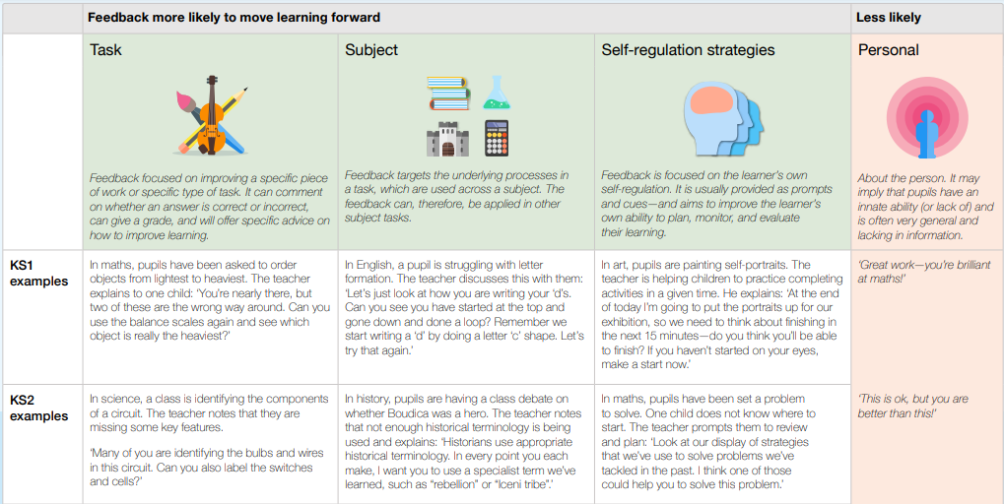
At the same time, the Independent Teacher Workload 2016 Review Group lists the following principles in their report “Eliminating unnecessary workload around marking”:
- Marking should serve a single purpose – to advance pupil progress and outcomes. The most important person in deciding what is appropriate is the teacher.
- Oral feedback, working with pupils, reading their work – all help teachers understand what pupils can do and understand.
- Consistency across a department or a school is still important, but this can come from consistent high standards, rather than unvarying practice.
- The time taken to mark does not always correlate with successful pupil outcomes and leads to wasted teacher time.
- Feedback can take the form of spoken/written marking, peer marking and self-assessment.

In a well-controlled experiment, Ruth Butler (1988) found that comments, rather than grades, improved student learning. When you give students a pre-test and then share only their grades, there is no gain in the post-test scores. The students who score high have a positive attitude, while those who score poorly have a negative attitude about their performance. But when students are given comments without grades, not only is there a gain in post-test scores, but students have a positive attitude, regardless of their initial performance. The bottom line is that grades promote an ego orientation to learning while comments promote a learning orientation.

Finally, as Dylan Wiliam stated at a training session in 2020: “Feedback should be a medical examination rather than a post-mortem – the point of feedback is not to improve the work but to improve the student”.

Pupil Voice
In June 2021, a pupil voice survey was carried out at Rodmersham to collect the views of the children on feedback and marking. The children were asked what kind of feedback and marking helped them to improve and which activities were less likely to help them improve. The table below shows the results from children in KS2.

KS2 Children’s View on Feedback and Marking

What we like and what helps us to improve | What we don’t like/doesn’t help us to improve
Positively phrased feedback | Copying up big writes after editing
The whole class feedback grid with our names in | Individual comments in books are not more effective than whole class feedback and we don’t like all the symbols
Verbal feedback whilst we are working | One-to-one conferencing takes too long and we have to wait for our turn too long
Teacher reading our work out loud (helps you to hear how you can improve it)
Whole class marking of samples of children’s work (see example)
Best composite answer
(children who would like to know their score should be able to ask for it afterwards)
Cooperative peer marking (ideally with more than one person as different people pick up on different things)
Shared writing/shared dialogue
Real-time feedback
Peer-marking with points (like Y6 do)

Taking the research and pupil voice into account, we have defined the following principles of feedback at Rodmersham School.

Principles of Feedback at Rodmersham School
- To deepen learning and allow pupils to make good progress.
- To be rapid and immediate within lessons wherever possible.
- To employ a range of strategies that include live marking, whole-class feedback, self-assessment, peer-assessment as well as teacher assessment, which could be formal data points or regular low stakes testing / checks.
- To regularly look at pupils’ books to help ‘feedforward’ and plan effectively for lessons.
- To provide time for pupils to develop self-reflection.
What does feedback look like at Rodmersham School?
Feedback is a part of the school’s wider assessment processes which aim to provide an appropriate level of challenge to pupils in lessons, allowing them to make good progress. Feedback will be specific to the subject and specific task the pupils have carried out as well as relevant self-regulation strategies. The type of feedback should be decided upon by teachers within each class and chosen on the basis of maximising learning. Written comments should only be used where they are accessible to students according to age and ability.
The following sections provide an overview of a range of feedback (and feedforward) strategies deployed at our school:
Generating Success Criteria
- Children are presented with examples (good, bad and brilliant) of the task they are about to complete.
- They identify the elements that make the examples good, bad or brilliant and, in doing so, generate a list of success criteria that they can refer to whilst completing the task.
Live marking
- Immediate marking of the work by the teacher. Students act immediately on this during in-class feedback.
- Teacher giving verbal feedback during lessons to small group, whole class or individuals. Students act upon this feedback.
- Consistent high-quality learning dialogue between teacher and student during the lesson. Students act upon this feedback.
- The teacher highlights misconceptions / incorrect work / poorly communicated subject knowledge whilst circulating in class. Students act upon this feedback.
Self-assessment
- We strive to have a supportive classroom environment where pupils are confident to read their work out in class and receive praise and feedback in front of their peers
- Whenever possible, the teacher provides students with the answers to mark their own work. This also helps their self-reflection, as it is instant feedback allowing them to consider if they understood the concept or not.
- Students consider their current learning against the success criteria and then improve their piece of work.
- This strategy could be combined with whole class feedback where you provide students with praise, misconception and/or errors made by the class in general.
- Share and ask students to pick out what is wrong and then re-draft correctly.
(Co-operative) Peer assessment
- Pupils share their work with each other and discuss what is great and what can be improved.
- Sharing good examples of students’ work at appropriate points in the lesson to allow students to reflect on their own work and share ideas for improvement.
- Photocopy examples of work, students to peer assess on the photocopied examples, then use what they have learnt from this activity to go back and improve their own piece of work.
Teacher marking
- Teacher provides written feedback on corrections/actions which need to be addressed next lesson.
- Use of written feedback on selected work for pupils to act on. A positive comment should be made which relates to the learning objective, a target where the success criteria have not been met and/or a suggestion or a question to allow opportunity for further progress.
- This strategy could be combined with whole class feedback where you provide students with an overview of praise, misconceptions and/or errors made by the class in general.
One-to-one conferencing
- This is a time-consuming way to provide feedback and can therefore not always be used.
- It allows teachers a concentrated period of high-quality teaching time with individual pupils.
- Teachers can discuss with pupils not just their progress but their progress in learning itself.
- It may allow pupils the space to self-develop and determine, by themselves, the trajectory of their learning.
- This strategy is especially useful with struggling students, as it can provide teacher and pupil with an opportunity to discuss the barriers that are preventing them from learning to the best of their ability.
Best composite answer
- The day after a test, pupils are given back their unscored papers and are asked, in groups of four, to produce the best composite response they can.
- Then a whole-class discussion of the groups’ responses follows.
- This way, a test that was designed originally for an entirely summative purpose, is being used to improve learning.
Whole class feedback
- A detailed description of this can be found in The Feedback Pendulum (Michael Chiles)
- Teachers create a “crib” sheet summarising the successes and areas for improvement for the class, based on (a sample of) children’s work (see below for an example).
- (Part of) the next lesson is used to discuss and use this feedback, allowing the children to improve on their own work.

Hinge questions
- Use of diagnostic questions (usually multiple choice) asked at the point in the lesson called the 'hinge' where you need to check if your pupils are ready to move on.
- The responses give evidence about what you and your students need to do next.
- Plickers is a great tool to use for this.
Standards and Expectations of Presentation
- All books/folders must have the following clearly stated: Student name, Subject, Year Group
- There should be no other form of writing or drawing on the cover of the book (except if they have their own book covers designed).
- Internal layout:
  - All written work should begin with DUMLUM (Date, Underline, Miss a Line, Lesson objective, Underline, Miss a Line). They should be underlined using a ruler.
  - Handwriting should be neat and legible.
  - All written work should be completed in black or blue pen; pupils will use pencil whilst they develop fluency and speed and will progress to pen when their writing is neat and legible or when it is felt that this would help support progress. Only use a pencil for illustrations, tables, pictures and diagrams.
  - All crossing should be done with a single ruled line.
  - Worksheets and assessments must be glued in flat into exercise books neatly and in chronological order where possible. Sheets should be, ideally where possible trimmed to fit the books.
  - There should be no doodling/drawing/scribble anywhere in the books.

Leadership Monitoring

Leaders will monitor the work in students’ books to check the quality of education and the feedback that is being provided by the department/key stage.
We will carry out regular monitoring activities, in our Professional Development Meetings, and use a coaching approach as a tool to elevate discussions. Teachers will share their books regularly and a collaborative culture will be developed to maximise impact.
Discussions will take place with the allocated governor by the Quality of Education allocated member of staff 3 times a year.

